CONSOLIDATED EXAM QUESTIONS

AQUEOUS SOLUTIONS AND ACIDITY
Contents
CONSOLIDATED EXAM QUESTIONS 1
AQUEOUS SOLUTIONS AND ACIDITY 1
Syllabus 2
Properties of Water – 15.1-15.2 3
2017 S2 3
2020 S2 3
2023 S2 3
Solubility (Molecular/Ionic) – 15.3-15.6 4
2017 S2 4
2020 S2 6
2023 S2 6
Precipitation Reactions – 16.1 7
2017 S2 7
2020 S2 7
2023 S2 7
Concentration and Calculations of solutions – 16.2-16.5 8
2017 S2 8
2020 S2 14
2023 S2 14
Acids and Bases – 17.1-17.4 15
2017 S2 15
2020 S2 16
2023 S2 24

Syllabus
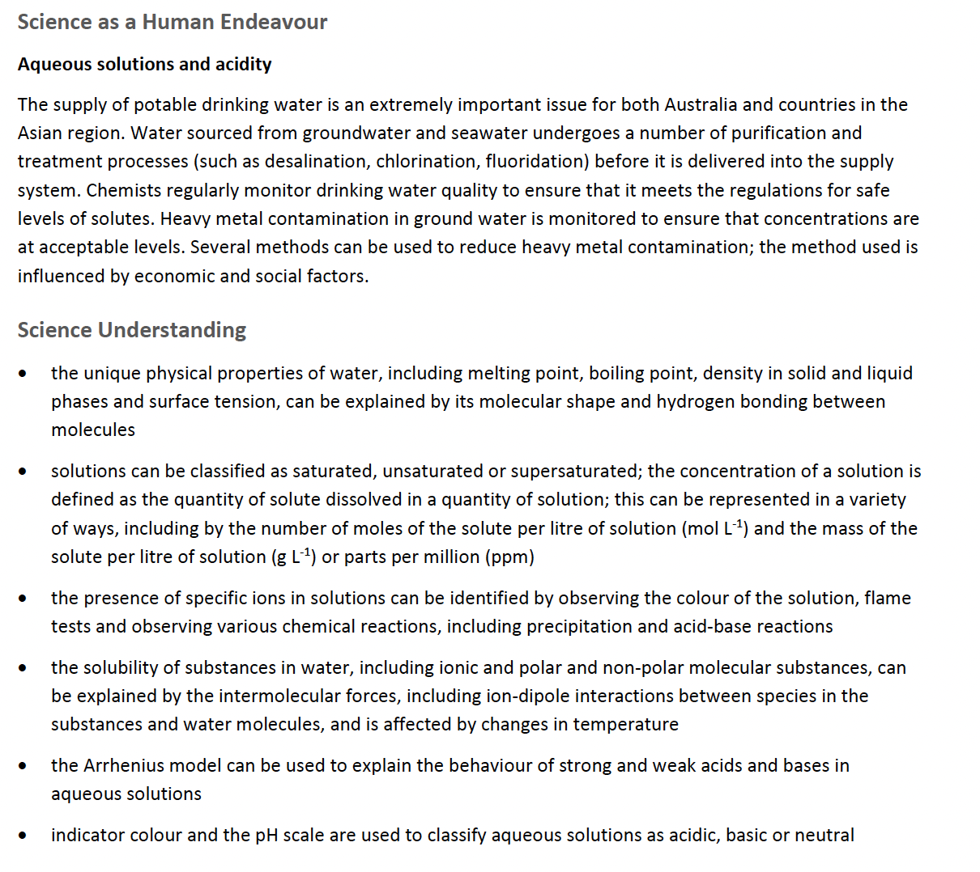
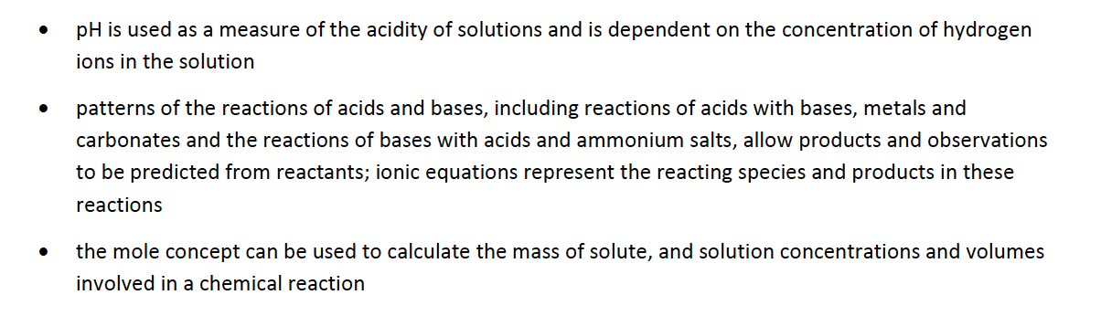

Properties of Water – 15.1-15.2

2017 S2
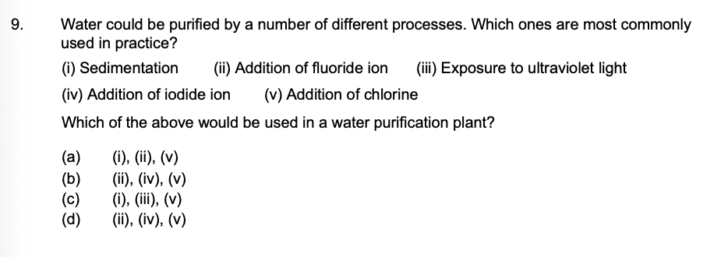

2020 S2

2023 S2
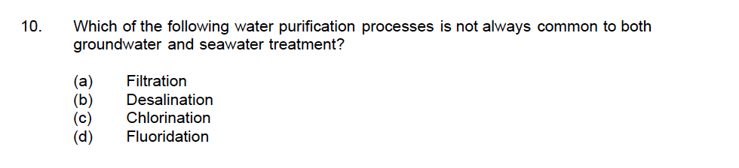
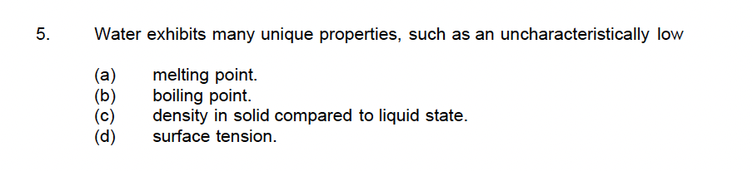

Solubility (Molecular/Ionic) – 15.3-15.6

2017 S2
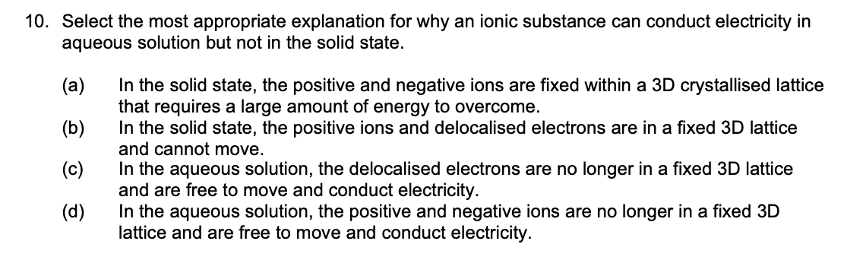
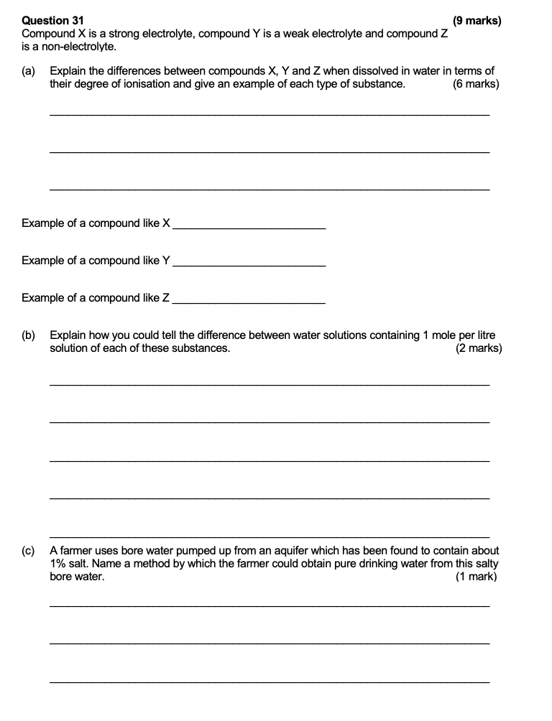

2020 S2
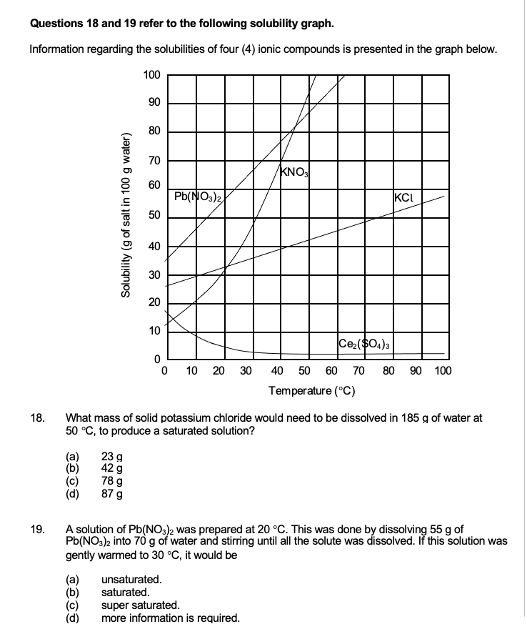

2023 S2

Precipitation Reactions – 16.1

2017 S2
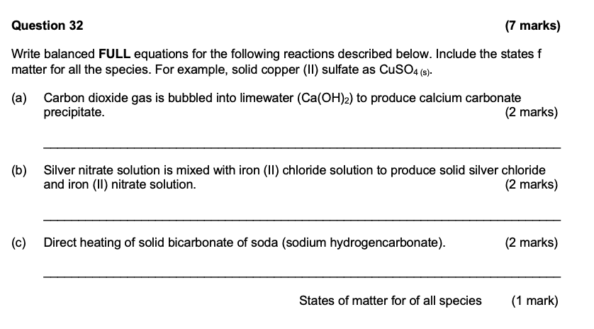
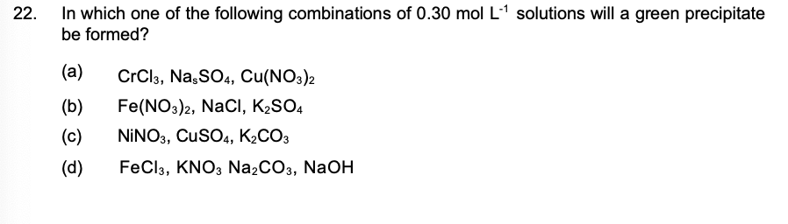

2020 S2

2023 S2

Concentration and Calculations of solutions – 16.2-16.5

2017 S2
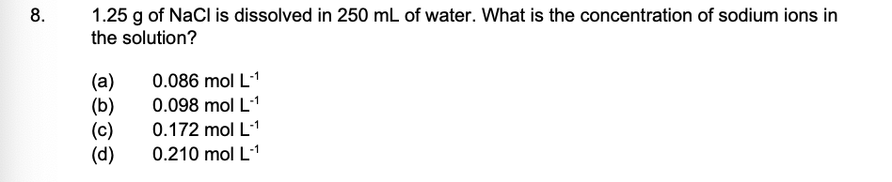
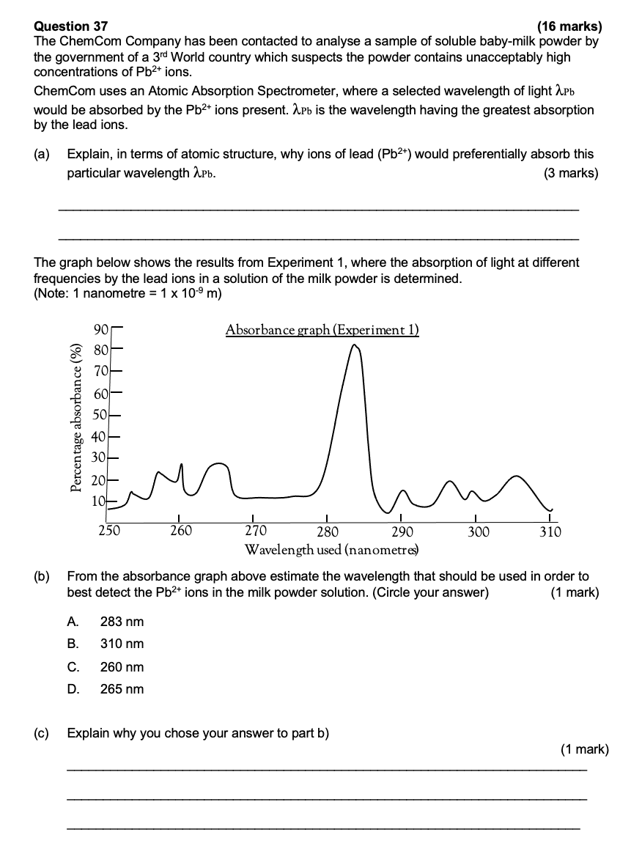
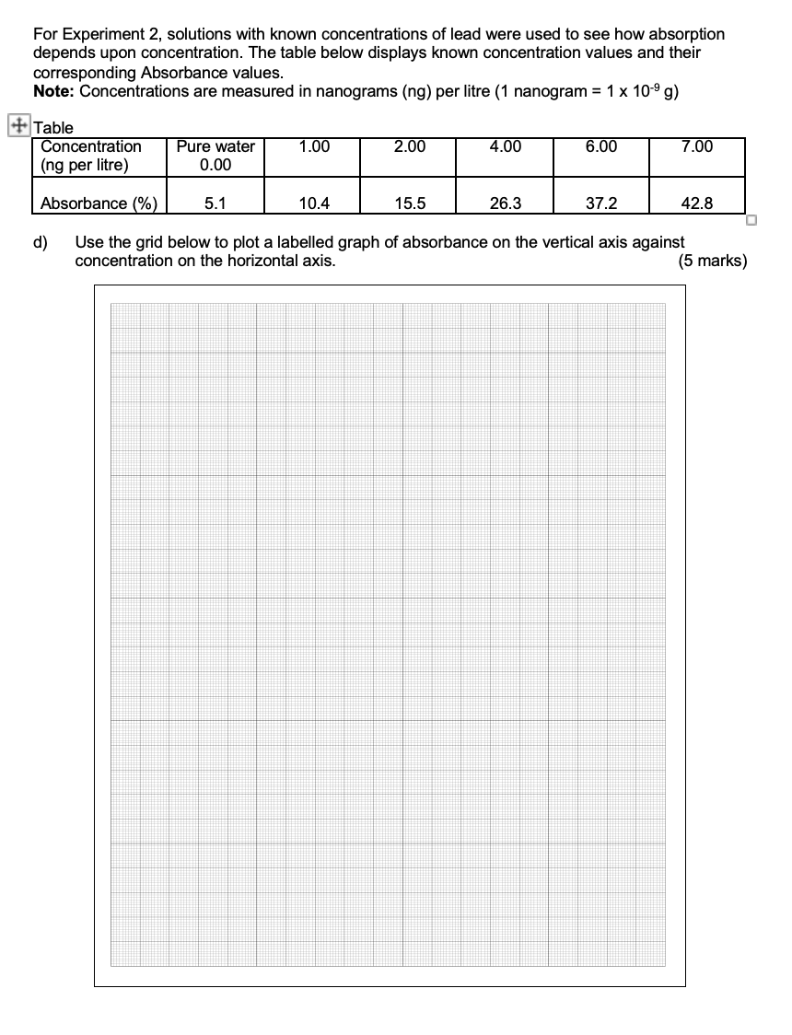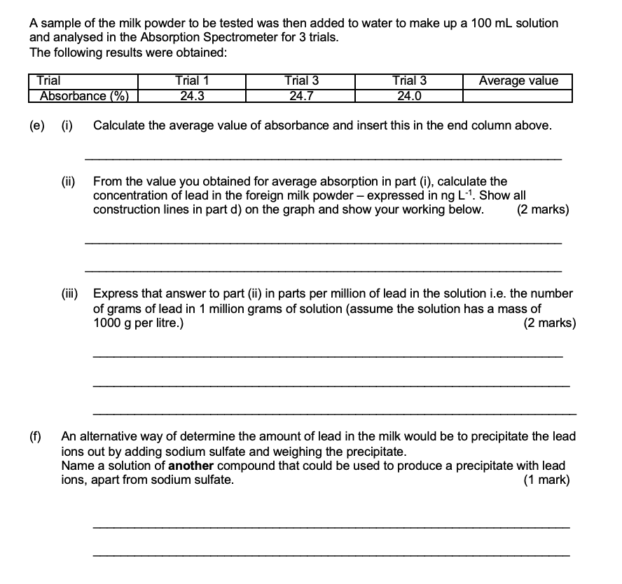
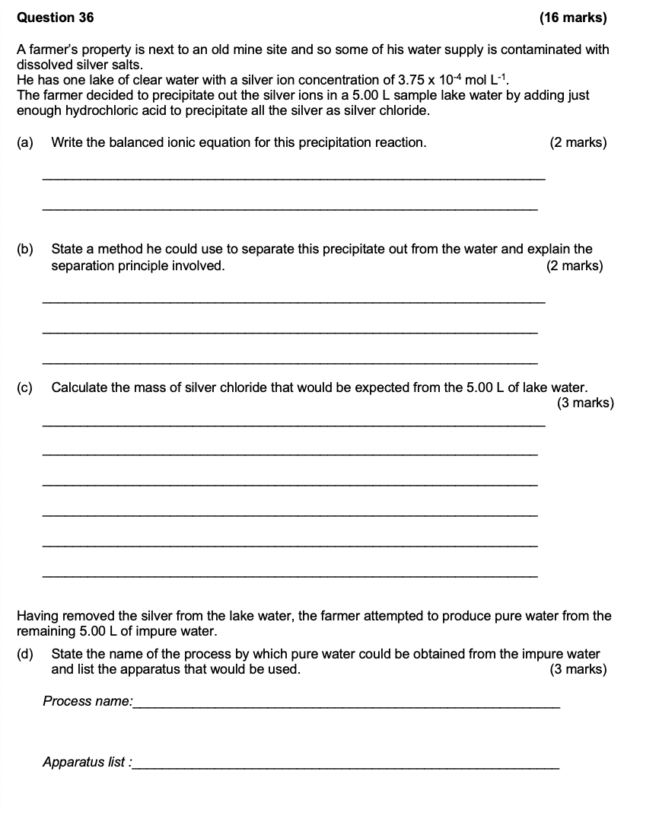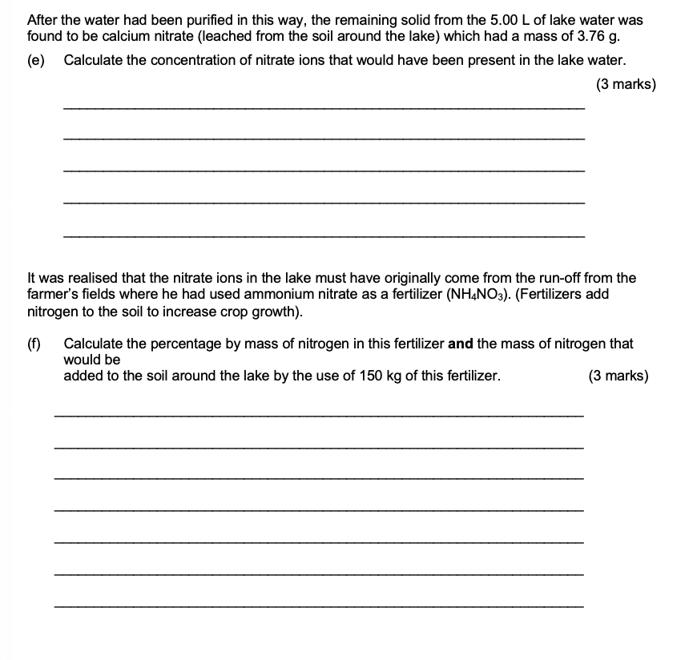

2020 S2
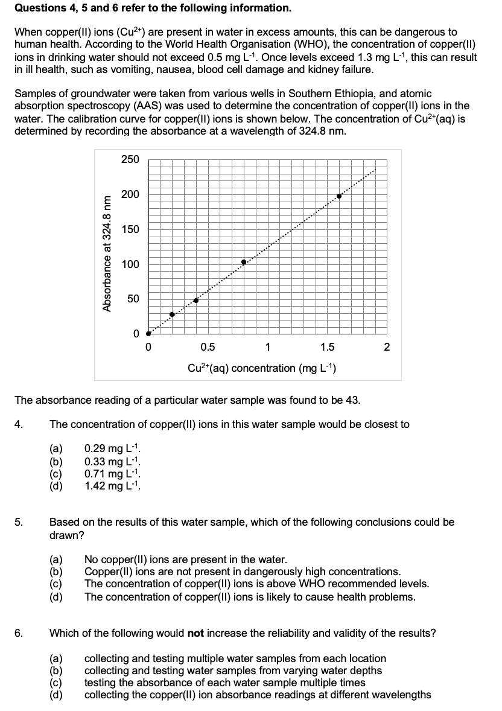

2023 S2

Acids and Bases – 17.1-17.4

2017 S2
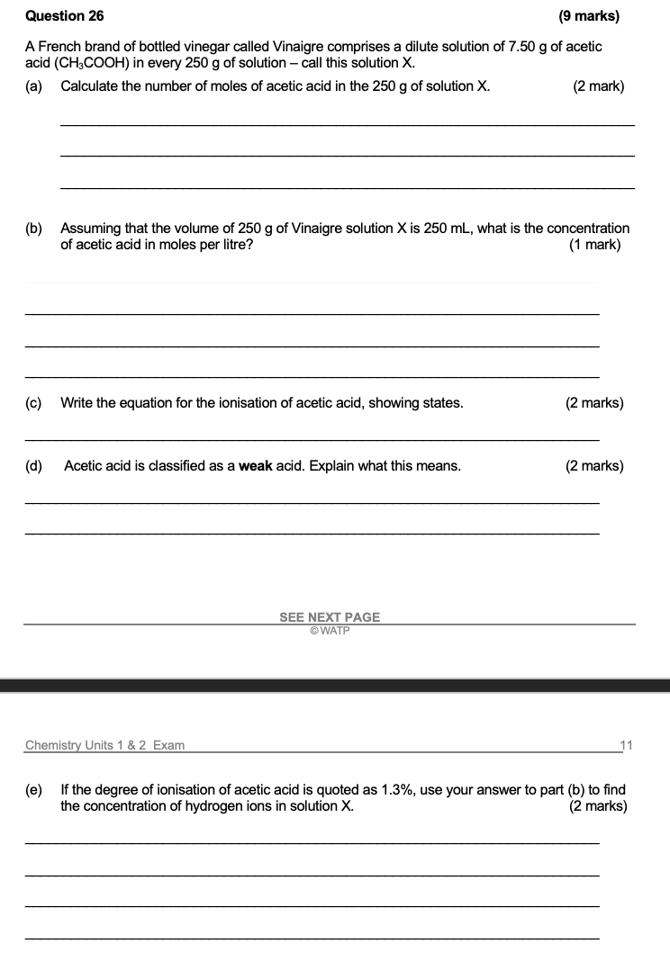
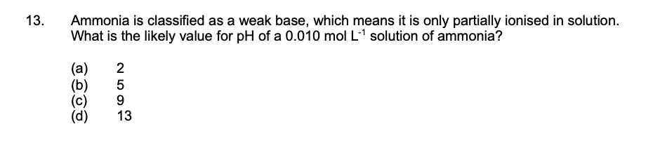

2020 S2
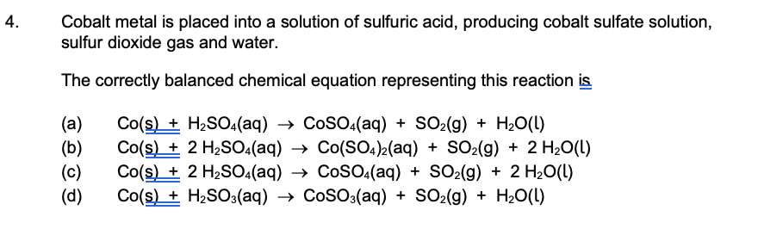
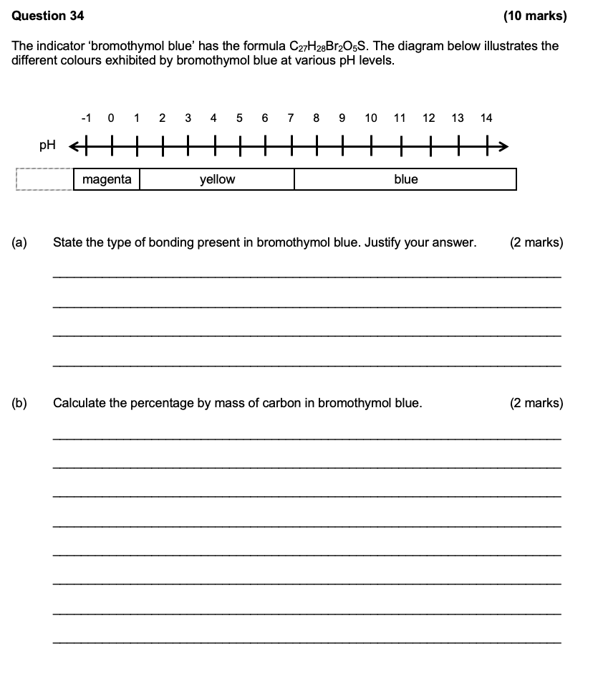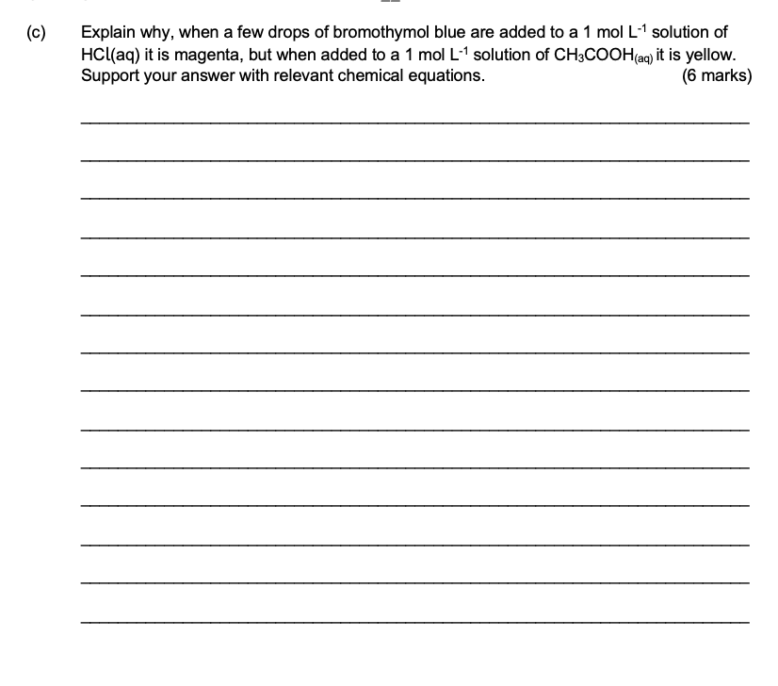
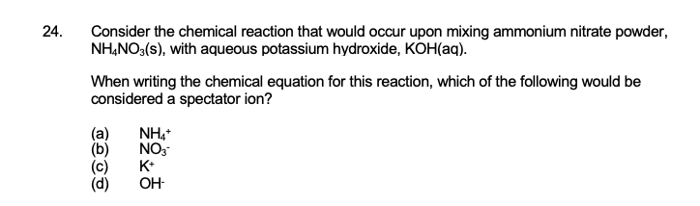
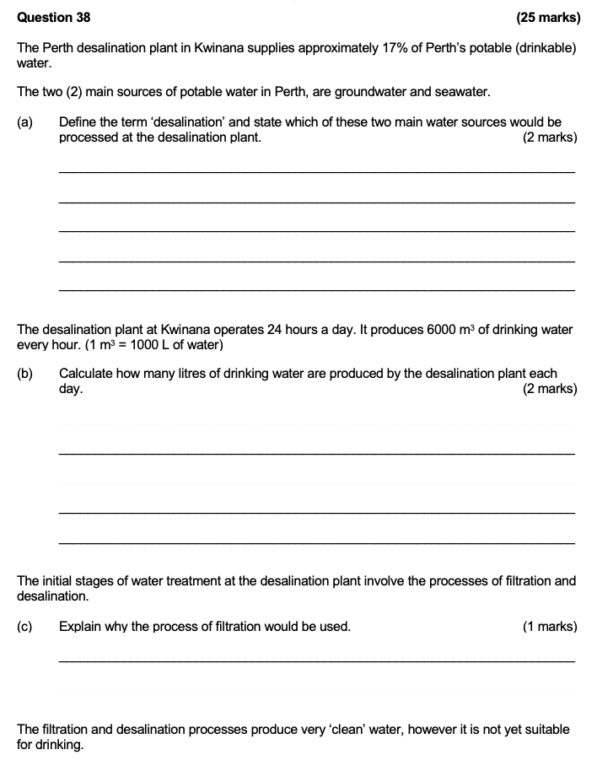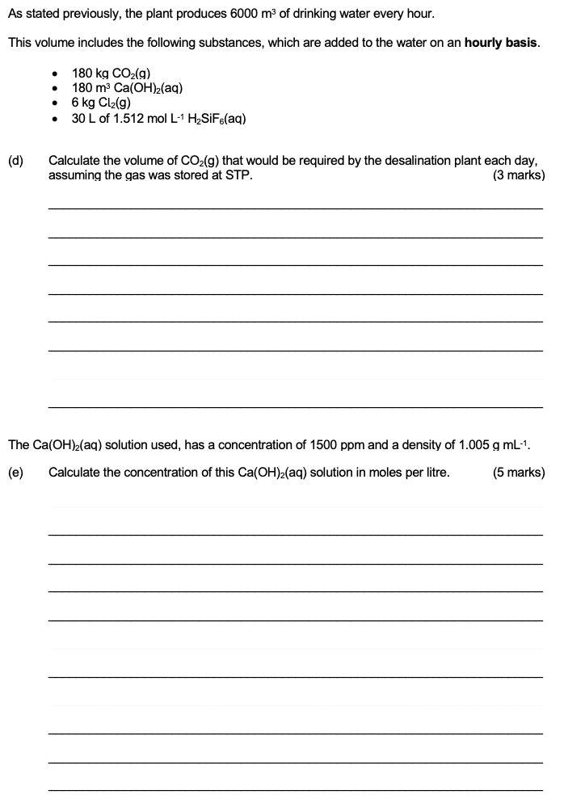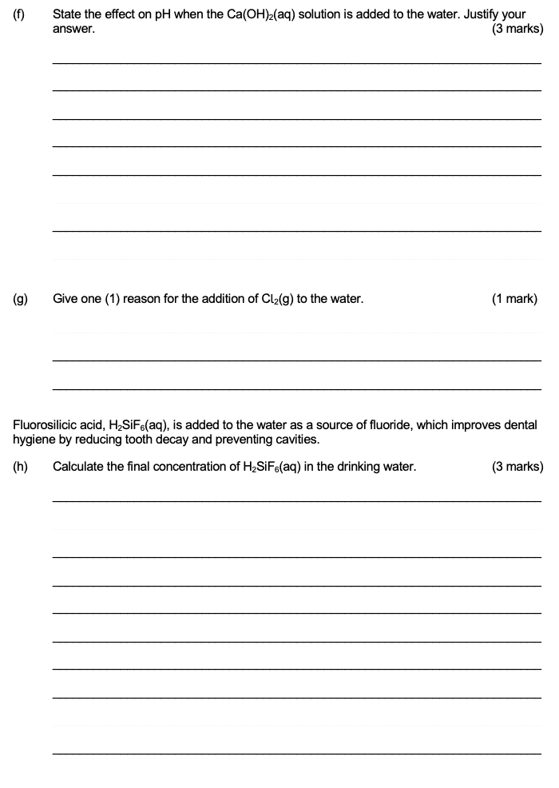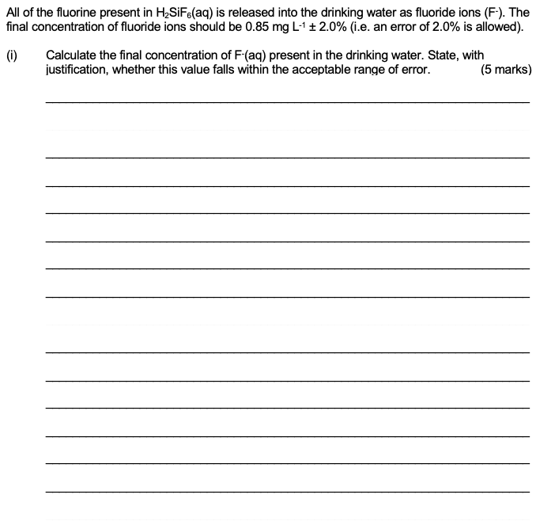
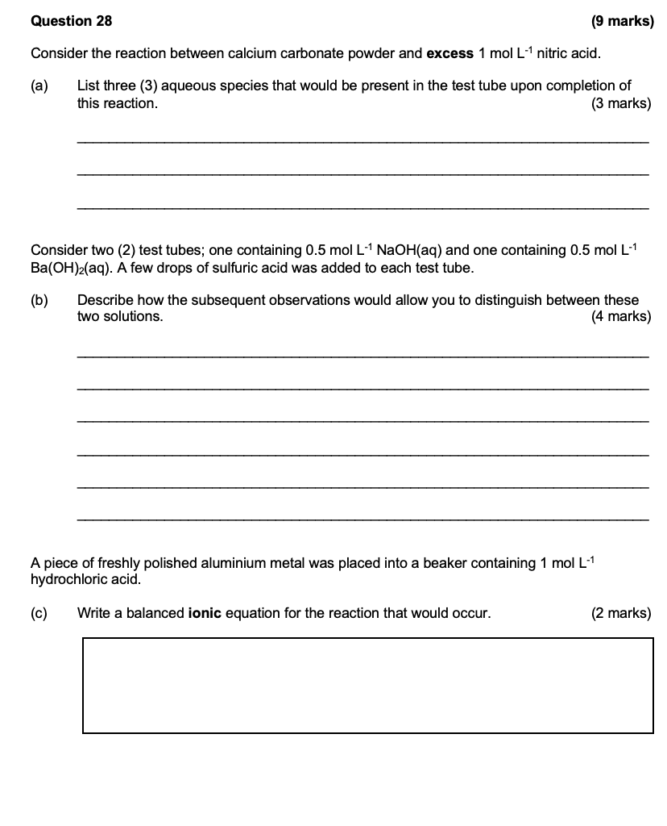

2023 S2

